LatCtrl

# LatCtrl Design Overview

信号输入：

|  |  |
| --- | --- |
| 名称 | 备注 |
| AsyLatCtrlModReqGroup | 表示横向控制模式，信号加了Check和Counter，来自仲裁模块 |
| DynCalPrmForBicycleMdlAxleDistFrnt | 质心到前轴距离Distance between front axle and centre of gravity |
| DynCalPrmForBicycleMdlCornrgStfnFrntByVehSpd | 车辆前侧偏刚度The vehicle front cornering stiffness |
| DynCalPrmForBicycleMdlCornrgStfnRetByVehSpd | 车辆后侧偏刚度The vehicle rear cornering stiffness |
| DynCalPrmForBicycleMdlJ | 车辆转动惯量Vehicle inertia around z-axis |
| DynCalPrmForVehM | 车辆质量The vehicle weight |
| DynCalPrmForVehWhlBas | 车辆轮距The vehicle wheelbase |
| DynCalPrmForVehSteerWhlAgRat | 转向比The vehicle steering wheel angle ratio |
| DynCalPrmForVehTyp | 车辆类型The vehicle type |
| DynCalPrmForVehicleSpdForBicycleMdlCornrgStfn | Vehicle speed break points used for finding the cornering stiffness |
| LaneMkr | 车道线信息，来自Sensor Fusion |
| Obstcl | 边界信息，来自Sensor Fusion，在内部写死 |
| RoadEdge | 道路边沿，来自Sensor Fusion，在内部写死 |
| PahDataFromTrfcJamAssi | PA轨迹数据，来自AutDrvCtrl |
| PinionSteerAgReq | 转向辅助请求，来自 CMbB(Steering Assistance) |
| PinionSteerAg | 方向盘转角信号，来自VDDM |
| SteerDataFromLaneKeepAid | LKA控制数据，来自lanekeepaidCtrl |
| SteerTqReqScaCoeff | Driver in Loop比例系数，来自STM |
| SteerWhlTqLimActvd | 方向盘力矩限制，来自STM |
| VehSelf | 自车数据，来自Sensor Fusion |

输出信号

|  |  |
| --- | --- |
| 名称 | 备注 |
| AsyPinionAgReq | LatCtrl输出的转角请求 |

# 2.Signal Extraction

1. 根据CtrlRef判断选取的是LaneMkr、RoadEdge、还是Obstcl的数据---LKAReferencePolynom
2. 根据ITC格式输出LKAPathData数据
3. 提取SplineX和SplineY、ValidSample点提取TJAPathData数据
4. 提取车身数据YawRate、VLgt—Vehicle Speed
5. 提取DILFactor参数
6. 提取SteerTorqueTqLimActvd 提取是否TorqueLimitActivation
7. 车身物理数据的直接传递

# 3.LatCtrl

## 3.1 Lateral Control Para meters

|  |  |
| --- | --- |
| 输入 | 备注 |
| VehicleSpeed | Ego vehicle speed |
| VehType | Type of the Vehicle |
| BicycleMdlMlnLatCtrl | Vehicle weight |
| BicycleMdlJlnLatCtrl | Vehicle inertia around z-axis |
| BicycleMdlAxleDistFrntlnLatCtrl | Distance between front axle and contre of gravity |
| BicycleMdlWhlBaslnLatCtrl | Vehicle wheelbase |
| BicycleMdlSteerRatlnLatCtrl | Vehicle steering wheel angle ratio |
| LateralControlModeRequest | Record of AS lateral mode request,with checksum and counter |
| BicycleMdlCornrgStfnFrntlnLatCtrl | The front cornering stiffness |
| BicycleMdlCornrgStfnRelnLatCtrl | The rear cornering stiffness |
| VForBicycleMdlinLatCtrl | Vehicle speed break points used to find the cornering stiffness values for front and rear.  The values are defined by LatCtrl for each vehicle type |

|  |  |
| --- | --- |
| 输入 | 备注 |
| LateralControlParameters | Parameters for the LatCtrl（Dim 73）包含速度阈值、加速度阈值、扭矩阈值 |
| BicycleModelParameters | Parameters for the BicycleModel（Dim 7） |

## 3.2 Compute Control Metrics

Signal input and output

|  |  |
| --- | --- |
| 输入 | 备注 |
| LateralControlModeRequest | 横向控制模式 |
| LKAPathData | LKA控制数据 |
| LKAReferencePolynom | LKA参考多项式 |
| TJAPathData | PA控制数据 |
| VehicleSpeed | Ego vehicle |
| LateralControlParameters | Control parameters |
| BicycleModelParameters | Model parameters |
| PinionAngle | 方向盘Last pinion angle |
| DILFactor | Driver in loop 比例系数 |
| TorqueLimitActivation | 方向盘力矩限制 |
| YawRate | 横摆角速度 |
| VlatError | 横向速度误差，反馈量 |
| LatCtrlTestBus | 原始数据都为0，结合LatCtrl参数进行修改 |

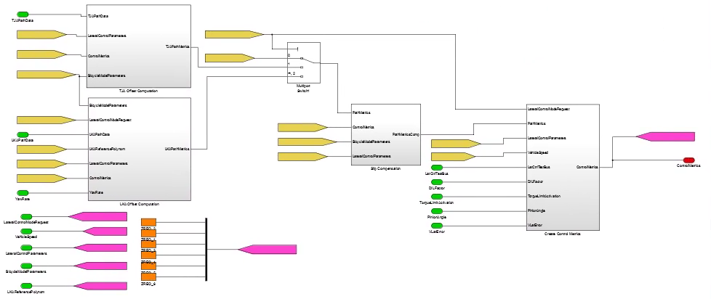

在该模块中，共有四个blocks，分别为：TJA Offset Computation、LKA Offset Computation、Slip Compensation 和Create Control Metrics

### 3.2.1 TJA Offset Computation

|  |  |
| --- | --- |
| Input signal | describe |
| BicycleModelParameters | Bicycle model parameters |
| LateralControlModeRequest | Lateral control mode（intervention） |
| TJAPathData | PA Path data |
| ControlMetrics | Control parameters |

|  |  |
| --- | --- |
| Output signal | describe |
| TJAPathMetrics | PA Path data  [Δy,yL2,LocalHeading,Teff,Leff,ValidRange]  Δy为车辆中心到轨迹的距离  yL2为车辆欲瞄点到轨迹的距离 |

#### 3.2.1.1 TJA Offset Computation

**LatCtrlCalcPathEvaluationMetrics 欲瞄时间与距离计算**

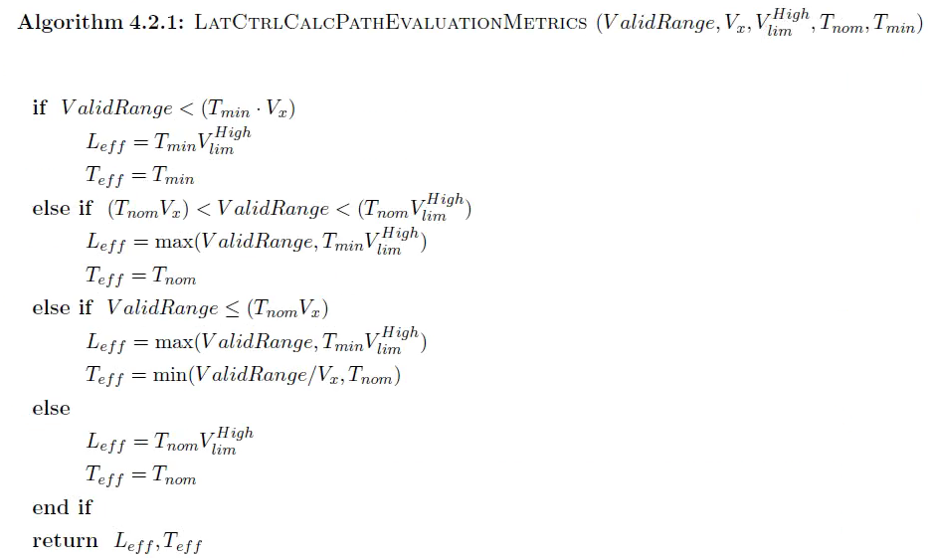

VaildRange由Evaluate Trail Length模块确定，输出的距离与车辆中心到后轴的距离LRear做差得到PA模块中的有效距离；

为车辆车速

在Create Control Metrics中计算得到

根据横向控制模式的不懂得到，PA控制时，=2s

不同模式下均相等，=0.4s

为欲瞄有效距离

为欲瞄有效时间

**TJA Spline Evaluation**

设：

这个公式根据代码中的形式给出，在Cubic Spline（三次样条插值）算法中通过三次多项式的一般格式可以给出：

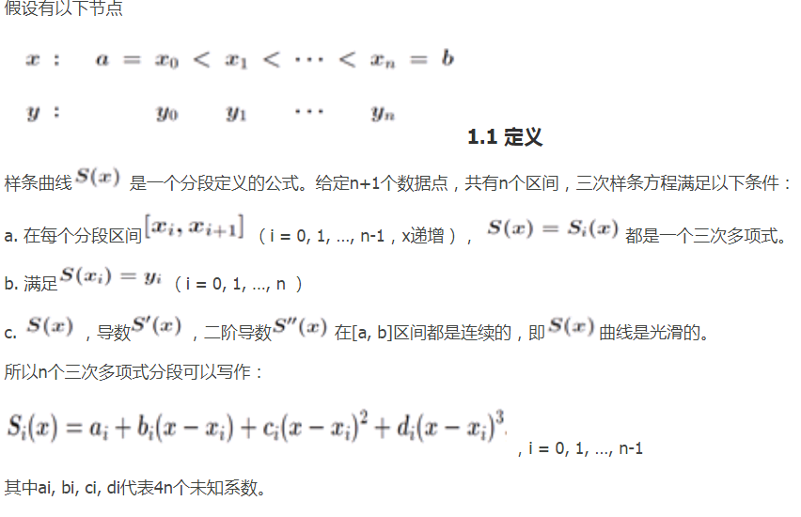

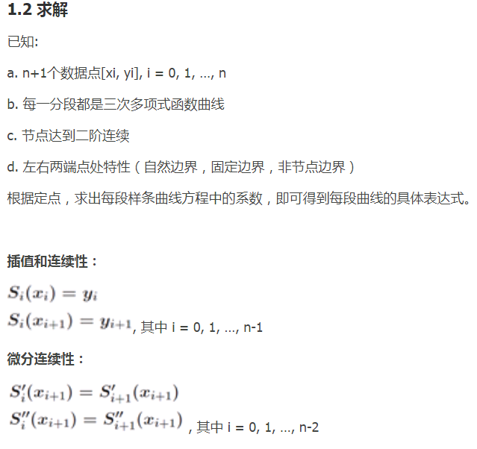

**对于该表达式，同样的通过一、二阶导数相等，求出系数a，b，即可得到表达式，从而确定**

### 3.2.2 LKA Offset Computation

|  |  |
| --- | --- |
| Input signal | describe |
| BicycleModelParameters | Bicycle model parameters |
| LateralControlModeRequest | Lateral control mode（intervention） |
| LKAPathData | LKA Path data |
| LKAReferencePolynom | Lane marking polynom |
| LateralControlParameters | Ego vehiclecontrol parameters |
| ControlMetrics | Control parameters |
| YawRate | Gyroscale value |

在LKA Offset Computation中共有三个计算模块，分别计算欲瞄有效时间/距离、

LatCtrlCalcPathEvaluationMetrics

|  |  |
| --- | --- |
| Input signal | describe |
| ValidRange | Road valid range |
| VehicleSpeed | Vehicle speed |
| VehicleSpeedLimited | Low speed limit High |
| LookAheadNominalTime | Nominal time |
| LookAheadMinimum | Minimum |
| LowrSpdLimforPathExtrap | 0 |

|  |  |
| --- | --- |
| output signal | describe |
| LookaheadEffectiveTime | Effective time |
| LookaheadEffectiveDistance | Effective distance |

有效时间和距离的计算公式如下



1. LKA Calculate Road Offset

|  |  |
| --- | --- |
| Input signal | describe |
| LateralControlParameters | Thresholds tunning parameter |
| WheelBase |  |
| LKAPathData |  |
| LKAReferencePolynom |  |
| VehicleSpeed |  |
| YawRate |  |
| LookaheadEffectiveDistance |  |

|  |  |
| --- | --- |
| output signal | describe |
| LKALocalRoadOffset |  |
| LKALookAheadRoadOffset |  |
| LKALocalRoadHeading |  |
| ValidRoadRange |  |

该模块主要是计算车到车道线的距离、车与车道线的夹角以及预瞄点到车道线的距离

在该模块中，当选择的车道线稳定是，需要进行车道线的滤波、稳定车道线的拟合参数

模块为LKA lane filter

计算输出LKALocalRoadOffset、LKALookAheadRoadOffset、LKALocalRoadHeading、ValidRoadRange

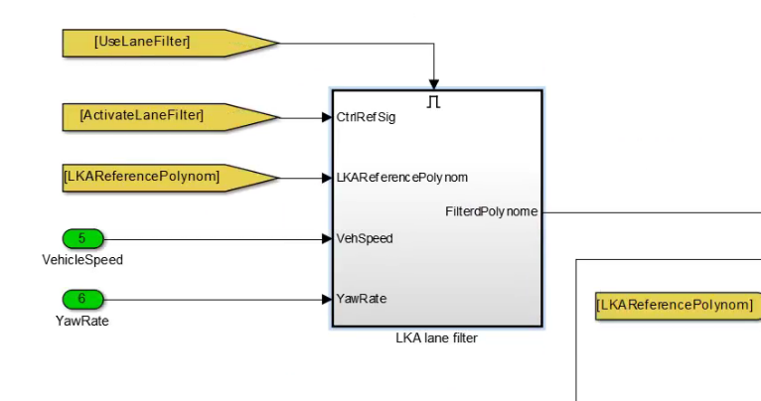

LatCtrl TestBus

|  |  |  |
| --- | --- | --- |
| OpenLoopMode | 0 | OpenLoopMode(0) |
| VlatRequest | 0 | 0 |
| YawRateClosedLoopRequest | 0 | 0 |
| PinionAngleClosedLoopRequest | 0 | PinionAngleClosedLoopRequest |
| LocalOffsetDisturbance | 0 | LocalOffsetDisturbance |
| ResetForTest | 0 | 0 |

1. LKA Calculate Path Offsets

|  |  |
| --- | --- |
| input signal | describe |
| LookaheadEffectiveTime |  |
| LKAPathData |  |
| VehSpdLgt |  |
| LateralControlModeRequest |  |
| LocalOffsetEffectiveTime |  |

|  |  |
| --- | --- |
| output signal | describe |
| LKALocalPathOffset |  |
| LKALookAheadPathOffset |  |
| LKALocalPathHeading |  |

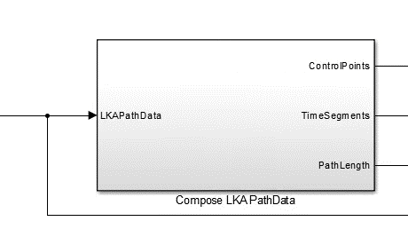

|  |  |  |  |
| --- | --- | --- | --- |
| Input Signals | describe | Output Signals | describe |
| LKA PathData |  | ControlPoints | 每段侧向加速度 |
|  |  | TimeSegments | 每段的时间 |
|  |  | PathLength | 时间总和 |

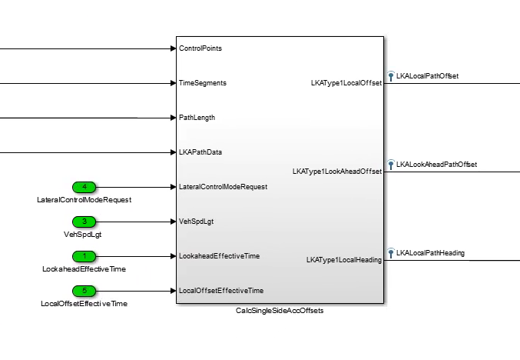

|  |  |  |  |
| --- | --- | --- | --- |
| Input Signals | describe | Output Signals | describe |
| ControlPoints |  | LKAType1LocalOffset | 车到轨迹线的距离 |
| TimeSegments |  | LKAType1LookAheadOffset | 预瞄点到轨迹线的距离 |
| PathLength |  | LKATypeLocalHeading | 车与轨迹线的夹角 |
| lateralControlModeRequest |  |  |  |
| VehSpdLgt |  |  |  |
| LookaheadEffectiveTime |  |  |  |
| LocalOffsetEffectiveTime |  |  |  |

### 3.2.3 Slip Compensation

模块中通过初始速度和位置，每一段的加速度计值和每一段的时间，积分速度，叠加到位置信息补偿侧偏角

|  |  |
| --- | --- |
| Input signal | describe |
| PathMetrics |  |
| ControlMetrics |  |
| BicycleModelParameters |  |
| LateralControlParameters |  |

|  |  |
| --- | --- |
| Output signal | describe |
| PathMetricsComp | 补偿后的 |

二自由度自行车模型计算

### 3.2.4 Create Control Metrics

配置控制器参数

|  |  |
| --- | --- |
| Input signal | describe |
| LateralControlModeRequest |  |
| PathMetrics |  |
| LateralControlParameters |  |
| VehicleSpeed |  |
| LatCtrlTestBus |  |
| DILFactor |  |
| TorqueLimitActivation |  |
| PinionAngle |  |
| VlatError |  |

|  |  |
| --- | --- |
| Output signal | describe |
| ControlMetrics |  |

#### 3.2.4.1 Determine Booleans

|  |  |  |  |
| --- | --- | --- | --- |
| Input Signals | describe | Output Signals | describe |
| LateralControlModeRequest |  | ResetController | 复位、模式变化（1） |
| VehicleSpeed |  | UseIntegration | 0 |
| LateralControlParameters |  | DILFactorDecreased | 驾驶员是否在环扭杠大（0）扭杠小（1） |
| LatCtrlTestBus |  | UseNonLinearLimitation | mode稳定True  选择后面的计算方法 |
| DILFactor |  | RampUpIntegrator | 扭杠介入（1）如果不介入（0） |
| TorqueLimitActivation |  |  |  |

Conparator w hystersis

迟滞计算，限定速度范围

DILFactorDecreased：驾驶员在环判断，DIL工作时该值为1，否则为0

#### 3.2.4.2 Determine Lower Gain Evaluation Speed

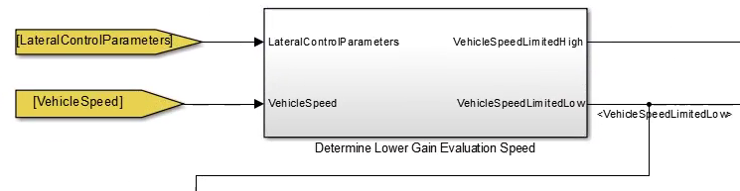

|  |  |  |  |
| --- | --- | --- | --- |
| Input Signals | describe | Output Signals | describe |
| LateralControlParameters |  | VehicleSpeedLimitedHigh | 输出汽车速度 |
| VehicleSpeed |  | VehicleSpeedLimitedLow | 下限值6m/s上下0.1做平滑 |

这里的速度在PA和LKA有效距离和有效时间计算中作为输入

#### 3.2.4.3 Calculate ALat and VLat Limit

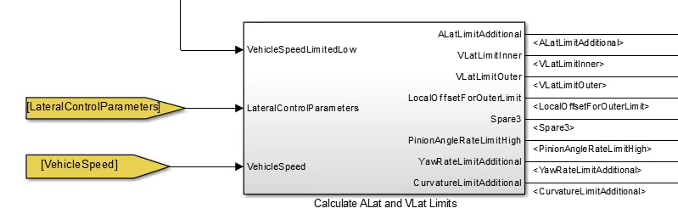

|  |  |  |  |
| --- | --- | --- | --- |
| Input Signals | describe | Output Signals | describe |
| VehicleSpeedLimitedLow |  | ALatLimitAdditional | 查表侧向加速度的阈值 |
| lateralControlParameters |  | VlatLimitIneer | 查表侧向侧速度的阈值 |
| VehicleSpeed |  | VlatLimitOuter | 查表侧向外侧速度的阈值 |
|  |  | LocalOffsetForOuterLimit | 外侧offset阈值1.5m |
|  |  | Spare3 | 0 |
|  |  | PinionAngleRateLimitHigh | 查表Pinionangle变化速率 |
|  |  | YawRateLimitAdditional | 查表向心力作用下yawrate变化率限制 |
|  |  | CurvatureLimitAdditional | 查表曲率变化率限制 |

#### 3.2.4.4 Calculate Controller Gains

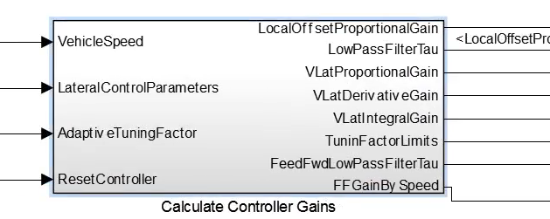

|  |  |  |  |
| --- | --- | --- | --- |
| Input Signals | describe | Output Signals | describe |
| VehicleSpeed |  | LocalOffsettProportionalGain | 查表 外环P （会乘以自适应系数） |
| lateralControlParameters |  | LowPassFilterTau | Effecitive Tau |
| AdaptiveTuningFactor |  | VLatProportionalGain | 内环P |
| ResetController |  | VLatDerivativeGain | 内环D |
|  |  | VLatIntegralGain | 内环I |
|  |  | TuninFactorLimits | 自适应调参中使用 |
|  |  | FeedFwdLowPassFIlterTau | 滤波中使用 |
|  |  | FFGainBySpeed | 查表增益（1） |

#### 3.2.4.5 Cal Additional Metrics

|  |  |  |  |
| --- | --- | --- | --- |
| Input Signals | describe | Output Signals | describe |
| LocalOffset |  | CurvatureDesired | 预判曲率 |
| LookAheadOffset |  | VLat | 当前横向速度 |
| LocalHeading |  |  |  |
| VehicleSpeed |  |  |  |
| LookAheadEffectiveDistance |  |  |  |
| ResetController |  |  |  |
| LateralControlParameters |  |  |  |

DeltayL2= LookAheadOffset- LocalOffset- LocalHeading* LookAheadEffectiveDistance

CurvatureDesired= DeltayL2*2/（LookAheadEffectiveDistance* LookAheadEffectiveDistance）

VLat= LocalOffset/TiStepInLatCtrl，微分得到当前的横向速度，在外环计算得到横向速度后得到速度的偏差

#### 3.2.4.6 Gain Sceduling